

(**Affiliated to Tribhuvan University)**

A CASE STUDY OF E-GOVERNANCE

**A CASE STUDY ON NICNET-ROLE OF NATIONALWIDE NETWORKING IN**

**E-GOVERNANCE**

|  |  |
| --- | --- |
|  |  |
|  |  |
|  |  |

SUBMITTED BY: SUBMITTED TO:

Name: Manisha kc Basanta Chapagain

Faculty: Bsc.CSIT ,6th sem (Department of CSIT)

Symbol NO:20809/075 Signature:

INTRODUCTION

National Informatics Centre(NIC),as a constituent unit under the then Department of Electronics, Government of India, providing Informatics services to government Departments and bodies since 1977, is undeniably the pioneer institution for e-governance in India. It has played a catalytic role in creating informatics awareness in government. NICNET, the nationwide satellite based network of NIC was established in 1985-86 for easy access of information for State and Central Governments across the nation, ensuring reliable, timely and accurate information for optimal use of resources.

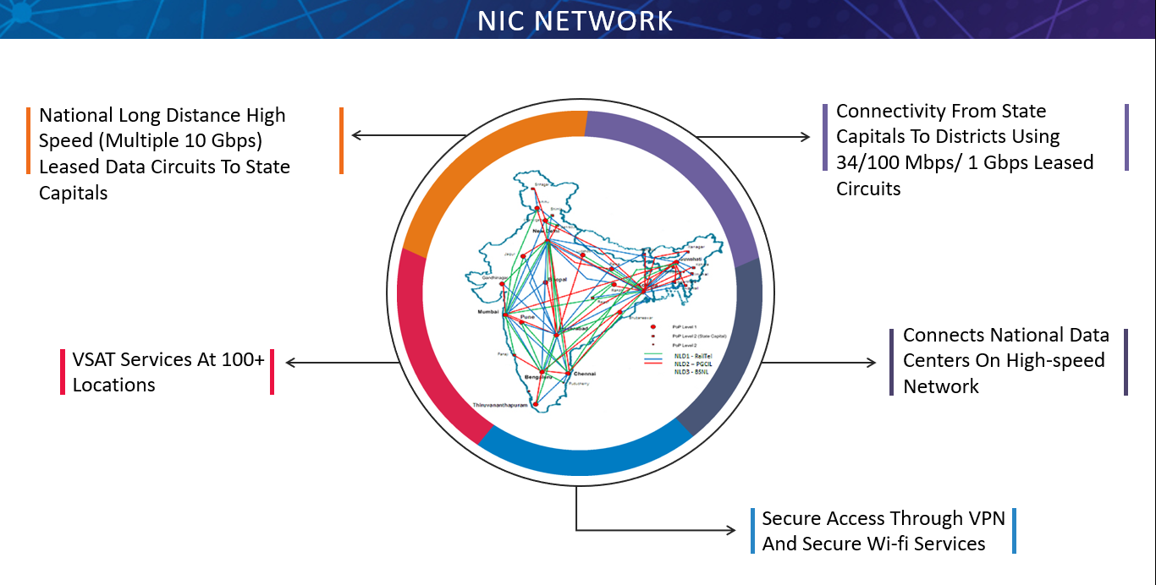

When Government of India approved NICNET, the National Informatics Centre had to evaluate various technology options of the day and come to an optimal solution for a nationalwide data network. The prospect of linking geographically disparate 600 odd districts and state capitals through terrestrial DOT lines was not viable in view of the then poor data handling capabilities of voice lines of the Department of Telecom and the cost and complexity involved in it. In view of our national success stories in satellite communication, be it in broadcasting, television or voice , a satellite based solution for the purpose of linking all the state capitals and district headquarters through a data network appeared most appropriate. It gave a solution which was distance-independent, cheap, scalable and easily deployable. Once the satellite option was made, the issue of mechanism of channel sharing was addressed . Since the already crowded C.band was the only available microwave band in the mid-eighties bandwidth was a scare resource and the satcom network envisaged gad to use it optimally. To provide two way communication to a large number of nodes using classical Time Division Multiple Access(TDMA/Frequency Time Division Multiple Access (FIDMA)mechnaisms of carrier sharing were not feasible unless costlier and comlex sharing mechanisms were incorporated.

Hence it was decided to go for a Code Division Multiple Access (CDMA) based on Very Small Aperature Terminal (VSAT) networking under the NICNET programme. Commercially viable, cheap VSATS in C-band using CDMA Spread Spectrum technologies were available which enabled using thousands of nodes for the same carrier in the two-way data link. The advantages of the CDMA VSAT option chosen were specifically

* Small size (1.2 m dia)
* Low cost
* Ease of installation and deployment
* Easy scalability

The VSAT had a 1200 bps uplink and 19.2 kbps downlink, though a few VSATs had an uplink of 9600 bps. This low speed was, of course, a limitation. However it was felt that, for the character-mode government transactions of mid eighties, this C-band VSAT network provided an optimal technology. Within one year of its conception, ie, in May 1985, the VSATS sprang up throughout the country dotting all State capitals and District Headquarters of Government. How did it help in e-governance? Let us probe into this using VSATS as communication links some of the pioneering applications of NICNET in governance were the following:

(a) Electronic Mail for Government Communications. NICNET provided pre-internet, electronic mail to all, secretariats of state governments, ministries of Government of India, and district collectorate through a centralized e-mail service.

(b) Database Access. NICNET helped its users to access databases like GISTNIC (General Information Services Terminal-National Informatics Centre, MEDLARS (Medical Literate Analyis and Retrieval Systems), etc, from remote locations

(c) Telnet. NICNET enabled remote login of systems across the countes.

(d) File transfer protocol (FTP). NICNET enabled file transfer across States and Districts. This application was widely used for, applications like budget transmission, and election result analysis. These applications provided support to nascent e-governance efforts of Central ministries and State governments at the secretariat level, district collectorates and the judiciary. Regional passport offices, registrar of companies, high courts and Supreme court, central excise, doordarshan were some of the prominent users of the NICNET. Budget transmission, election result analysis, cause list Access of courts, company name registration, were some of the more important applications based on NICNET. Accessing Medical Literature Analysis and Retrieval System (MEDLARS) database and General Information Services Terminal of National Informatics Centre (GISTNIC) database from remote corners of the country demonstrated the potential of data network in public administration.

With the advent of multimedia information on PCs and the slow but sure penetration of the Internet in the early ninetics, it was felt that the speed of transmission provided by the C-band NICNET was inadequate. Conscious of the catalytic role played by the NICNET in e-governance, NIC decided to provide a high speed overlay network over the C-band to provide higher data rates.

With great persistence and persuasion NIC succeeded in getting necessary approval for operating ku-band based VSA Accordingly, high speed Single Channel Per Carrier (SCPC) ku-band VSATs were installed in all major state capitals in the first phase. These provided speeds of 128 k-256 kbps. This overlay network was integrated with C-band and Internet. With the commissioning of this overlay on NICNET, all the services on the Internet like web access, e-mail, etc. became available at all NICNET nodes. Value-added services like video conference were also provided at SCPC nodes. This gave a new paradigm in government conferencing.

Subsequently, high speed ku-band VSATs were installed in several districts with all the services on internet accessible. Mailservers and RAS were configured and internet access made easy at district and sub-district level. This has made web-enabled application possible at even sub-district levels for e-governance applications.

NIC involved in implementing “e­Governance agenda” of the Central Government with respect to the following:

* Internet/Intranet Infrastructure (PCs, Office productivity   tools, Portals   on Business allocation) up to Section officers levels 42 IT Projects in India
* IT empowerment of Officers or Officials & Capacity Building
* ICT enabled Services (G2G, G2E, G2C and G2B)
* ICT plans for Sectoral Informatics Development Services profiles, among the others, include the following:
* Network services (WAN, MAN, LAN)
* Data mining and data warehousing
* Total ICT Solutions
* Video Conferencing & web services
* Certification Authority and PKI Services
* Domain (gov.in) Registrar
* Computer Emergency Response Team (CERT) Services
* National Disaster Recovery Centre
* Geometrics & Informatics design and development for decision support
* Sectoral ICT Plan formulation

NIC implemented and developed  a very large number of projects for various State  and Central Government Ministries and Organizations. Many of these projects are carried out by the divisions of NIC at New Delhi Headquarters and State/District centres in the country. The following are some of such projects:

* Agricultural Marketing Information Network (AGMARKNET)
* Community Information Centres (CICs)
* Court Information System (COURTIS)
* Department of Agriculture Network (DACNET)
* Examination Results Portal
* Land Records Information System (LRIS)
* National Hazardous Waste Information System (NHWIS)
* Training
* Video Conferencing

**AGAMARKET**

AGMARKNET stands for Agricultural Marketing Information System Network. It is a procedure sponsored by the Directorate of Marketing and Inspection (DMI), Ministry of Agriculture and executed by the Agricultural Informatics Division of NIC for linking important agricultural produce markets in the country. Towards globalization of Indian Agriculture, the NICNET ­based AGMARKNET produces transmission and generation  of prices and arrival information from agricultural Information Systemsproduce markets and its webbased dissemination for the use of individual producers, farmers organizations, consumers, traders, NGOs, communication agencies(Radio, newspapers, TVs, web sites, food processing industries, Chambers of Commerce, policy makers).

**Community Information Centres**

Communication Information Centres (CICs) is an effort by Information Technology Department, NIC and the state Governments of the North­Eastern states. Each CIC centre is managed by two operators and provides G2C services  Web access, email, printing, data entry, word processing and IT training to the local people.

**Court Information System**

Court Information System (COURTIS) is being implemented by NIC to serve all stakeholders like Judges, Advocates, Litigants, Law Firms, Legal Institutions, Government, Researchers and General Public in the legal system. NICNET based COURTIS project interconnects the Supreme Court and all High Courts and is in the process of computerization and integration of all District Courts in India. The main components of COURTIS are Case Status, Judgment Information System (JUDIS), Cause Lists and Daily Orders on Internet.

**DACNET**

DACNET stands for Department of Agriculture Network. NICNET based DACNET is an project of e­governance executed by NIC. It provides dissemination and exchange of faster and reliable agricultural information across the Ministry of Agriculture and Directorates and Field Units of Department of Agriculture and Cooperation. It aims to improve work culture through better transparency, streamlining of existing administrative and technical methods and practices, greater integration and use of the data collected from variety of data sources, moving towards a paperless office environment, , knowledge sharing and research. DACNET supports Decision Making for planners, integrates Government to Government (G2G) functions, connects Agri­Business Partners (B2B) and Farmers (C2C) and ensures IT Empowerment of the Officials of the Directorate.

**Examination Results Portal**

The first source of Examination Results on the web is produced by the portal, that is a one­stop source to get online results of various Academic, Entrance and Recruitment examinations conducted by various government agencies. CBSE, State Education Boards, Universities, Professional Institutes (Engineering, Medical, MBA, CA, etc), Central and State level entrance examinations for Medical, Engineering, MBA, etc. and Staff Selection Commission (SSC) and other recruiting agencies using this portal to deliver the results. 45 Information Systems

**LRIS**

LRIS stands for Land Records Information System. LRIS is used for realizing the needs of land management. NIC in association with the Ministry of Rural Development, Government of India has developed a computerized Land Records Information System (LRIS) targeted at farmers, landowners, administrators, planners, decision makers and for resources related to revenue, survey, agriculture, forest, irrigation and land resources. NIC contributes in Configuration Management, Human Resources Development and Technology upgradation. The system has acquired copyright under the name BHULEKH.

**NHWIS**

NHWIS stands for National Hazardous Waste Information System. NHWIS is an online database containing information of more than 10,000 hazardous waste generating industries. NHWIS serves as a compliance and enforcement tool for Central and State Pollution Control Boards and Ministry of Environment and Forests. It provides updated information on Hazardous Waste Management to the policymaking, implementing authorities, consultants, NGOs and general public and is useful in urban and industrial planning process and in exploring investment opportunities

**IT Training**

NIC  offers IT related trainings at its centres located all over the country to fulfill the current   and   future   IT   needs   of   Government   Administration   and   Public   Sector Undertakings.   A   wide   variety   of   training   programmes   have   been   designed   to implement e­governance at all levels, such as Executive Development Programmes, Office   Productivity   Tools,   Sectoral   Development   Programmes,   DOP&T   Training Programmes   for   IAS   Officers,   DOL   Trainings   in   Hindi,   Customized   Training Programmes and Technology Update Training Programmes for NIC Officers. The spectrum of technologies covered include Application Development Programming, Database   Technologies,   OS,   Networking,   Video   Conferencing,   Internet/Intranet Technologies, Web Authoring Tools, GIS, CAD/CAM, Utility Mapping, MEDLARS, Office Productivity Tools, Digital Certification, etc.

**Video Conferencing** NIC has been providing videoconferencing services over its high speed satellite­based network called NICNET. This is the largest videoconferencing network in India connecting 127 cities including all north­eastern state capitals. The network used is a SCPC VSAT link operating at 128 Kbps from each of the 127 locations which are connected to Delhi in a star configuration. NIC is also using ISDN lines for many 46 IT Projects in India Central and State Government ministries. Its portable SCPC VSATs can facilitate videoconferencing and high speed internet connectivity from any place in India. With its Multipoint Conference Server (MCS), NIC can provide videoconferencing service to any organization under the NICNET domain, enabling several sites to participate in a live conference with audio ­video and document sharing

**CONCLUSION**

In this case study we have seen how a national Wide Area Network (WAN) for India. NICNET, was set up as early as 1986, the first government informatics network in the world. We have also seen how this network was pioneering government applications of e-mail, telnet, ftp and Internet. Database services as GISTNIC and MEDLARS were also offered on telnet at a very early date (1989). NICNET was upgraded to meet the present day requirements of the government at various levels.

With the demand for bandwidth growing exponentially and optical fibre circuits providing economical abundant bandwidth resources across the country, NIC has started integrating its network with fibre optics circuit (foc) in major state centers like Hyderabad, Chennai, Mumbai, Trivandrum, Bangalore, etc.. and by 2004 end NICNET will have a minimum 2 Mbps foc fink connecting its state units with its main hub at New Delhi.